Running OEM Tuning advisor example

**Login to OEM as oracledba**

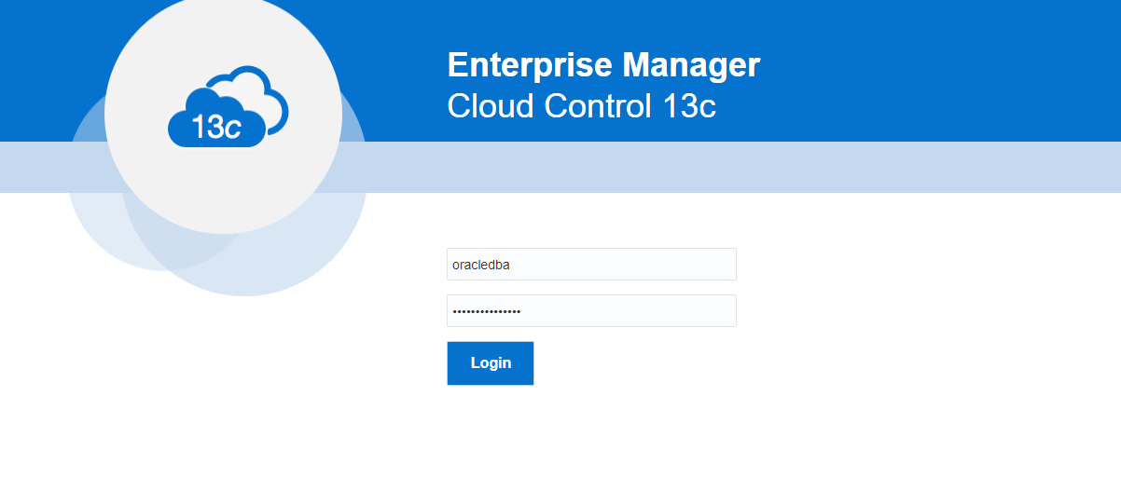

**Select database name in target search box**

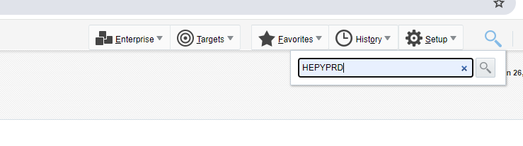

**Click on Primary database instance target (M in server name stands for Middletown which where Primary hosted)**

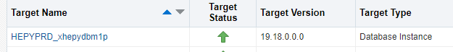

**If you were provided with SQL ID to investigate, go to directly to SQL Search screen**

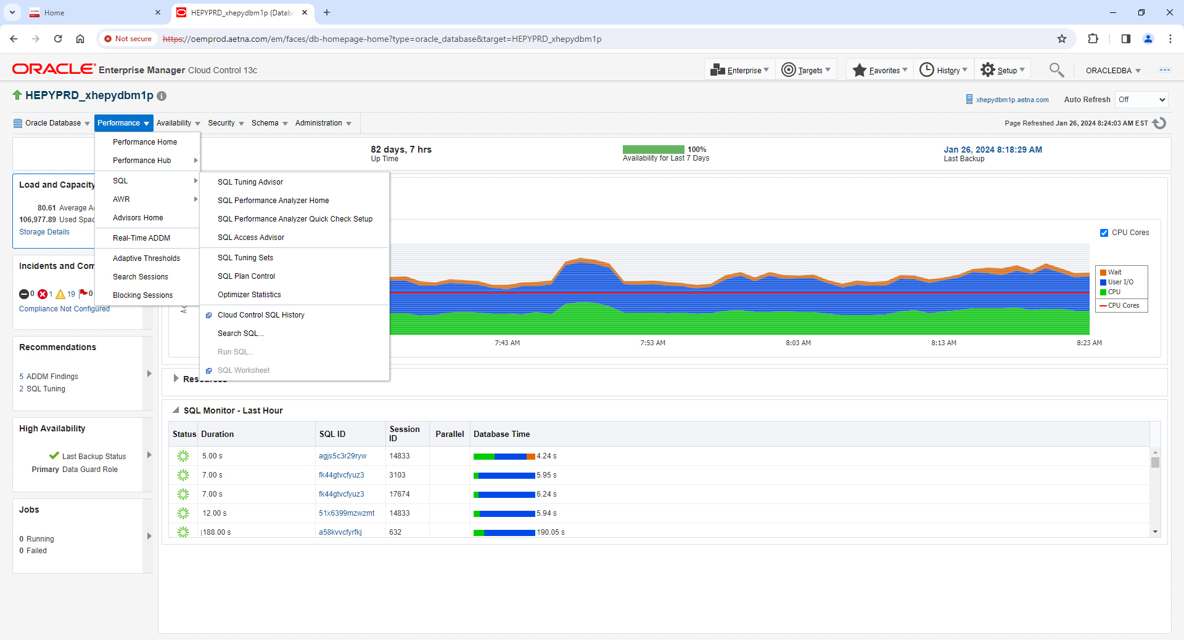

**If you need to figure out what SQL ID for particular query or job go to SQL Monitor screen**

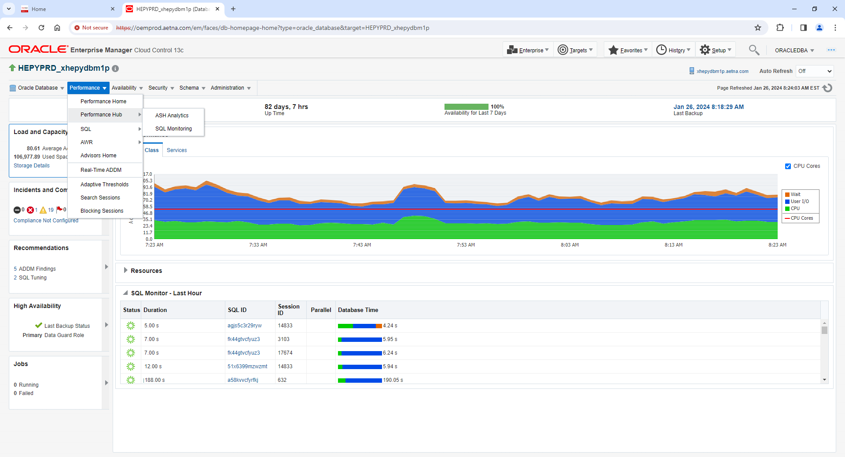

**From SQL Monitor screen you need to find SQL ID that in question based on Duration or query text itself. That information has to be provided by whoever paged you.**

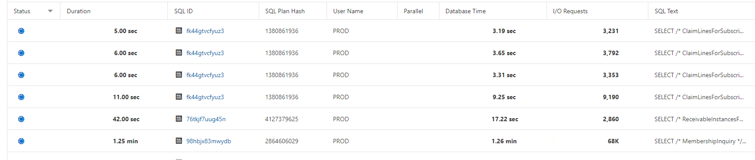

**Once you obtain SQL ID go back to Search SQL screen from where you need Log out from oracledba and log back in with Oracle Database Account. Either your AID if you have in this database or SYSTEM. Both Ps should be available in BT**

**Go to ORACLEDBA on top left and click down arrow. Where you need select Log out.**

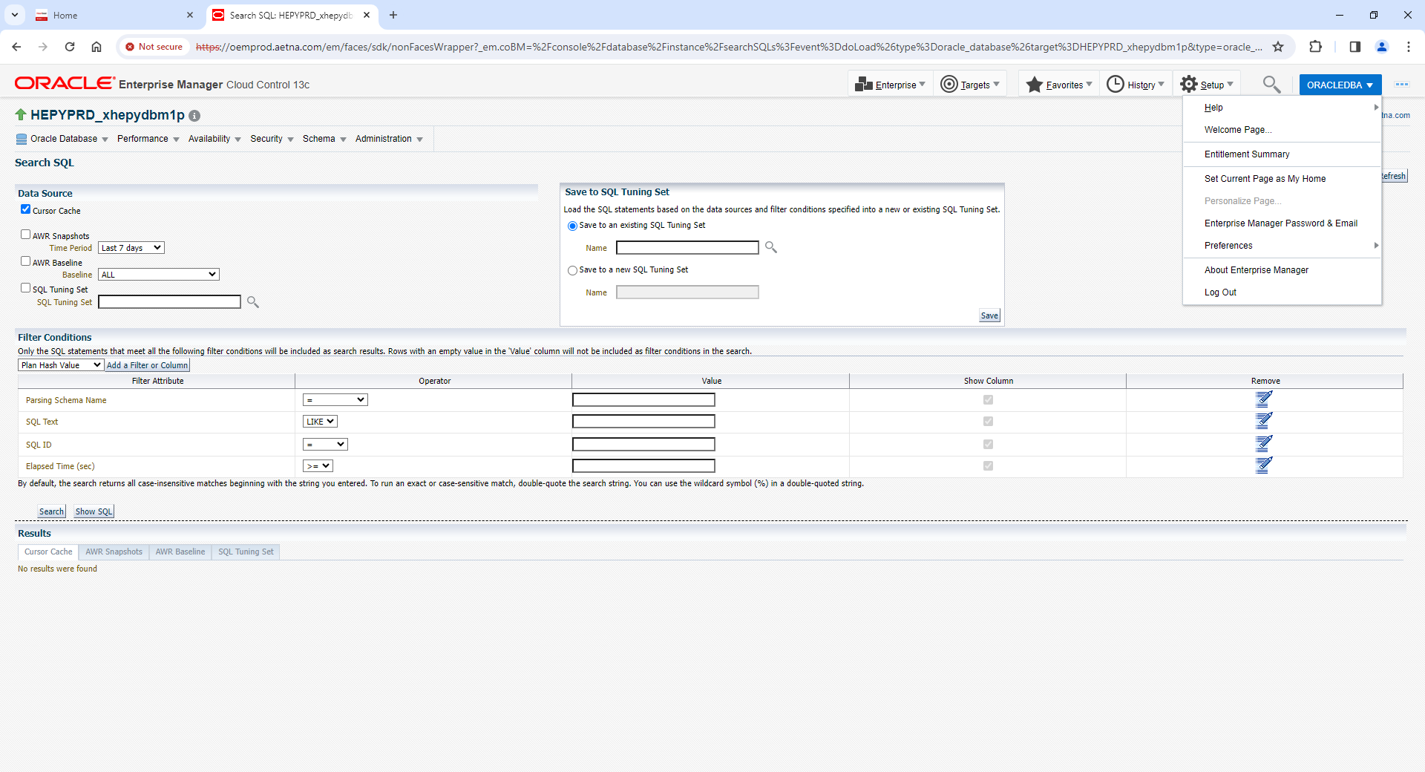

**Select Display login page after logout check box.**

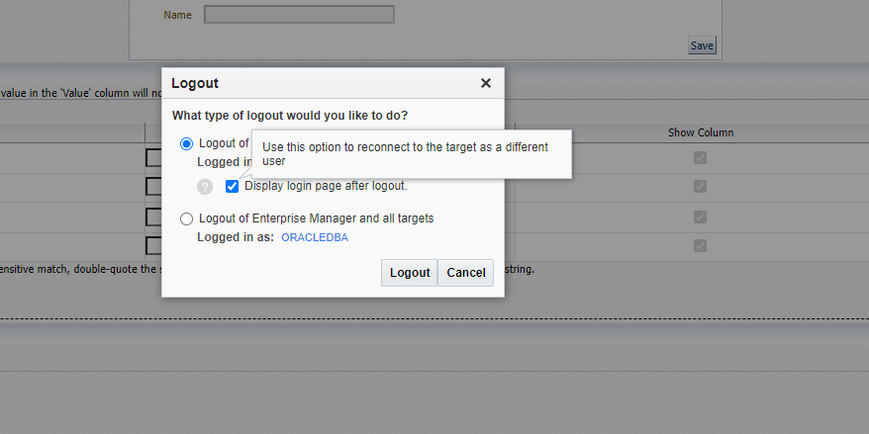

**Select New and provide your database credentials.**

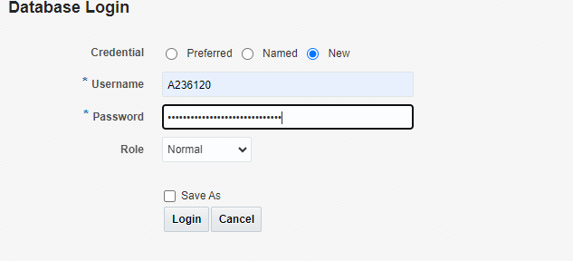

**Now you should be logged with database account. Example below where you can see on top left side**

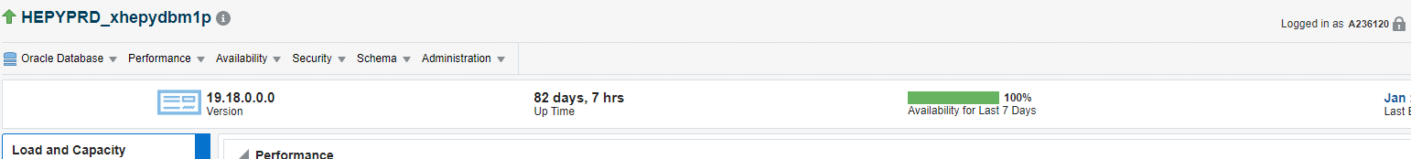

**Once you obtain SQL ID go back to Search SQL screen and paste SQL ID into SQL ID search box. Select AWR Snapshots and appropriate Time Period. Hit Search button.**

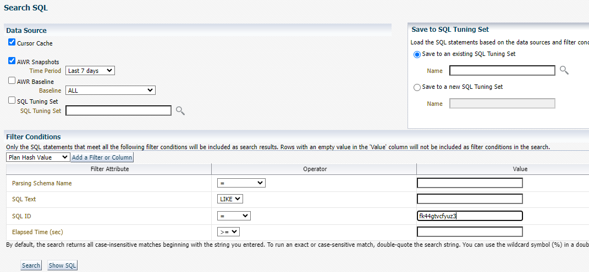

**Click on SQL ID link or SQL Text Link**

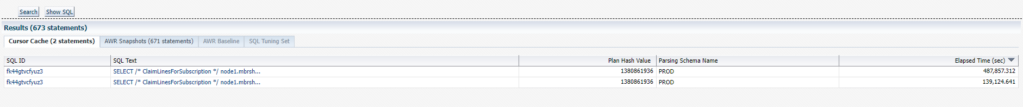

**It will bring you to Statistics Tab**

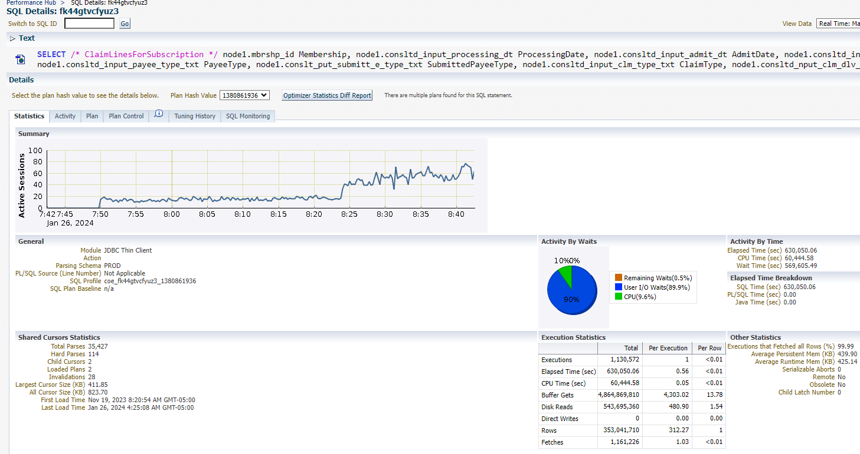

**From Screen above select SQL Tuning Advisor from Actions dropdown box. Click GO**

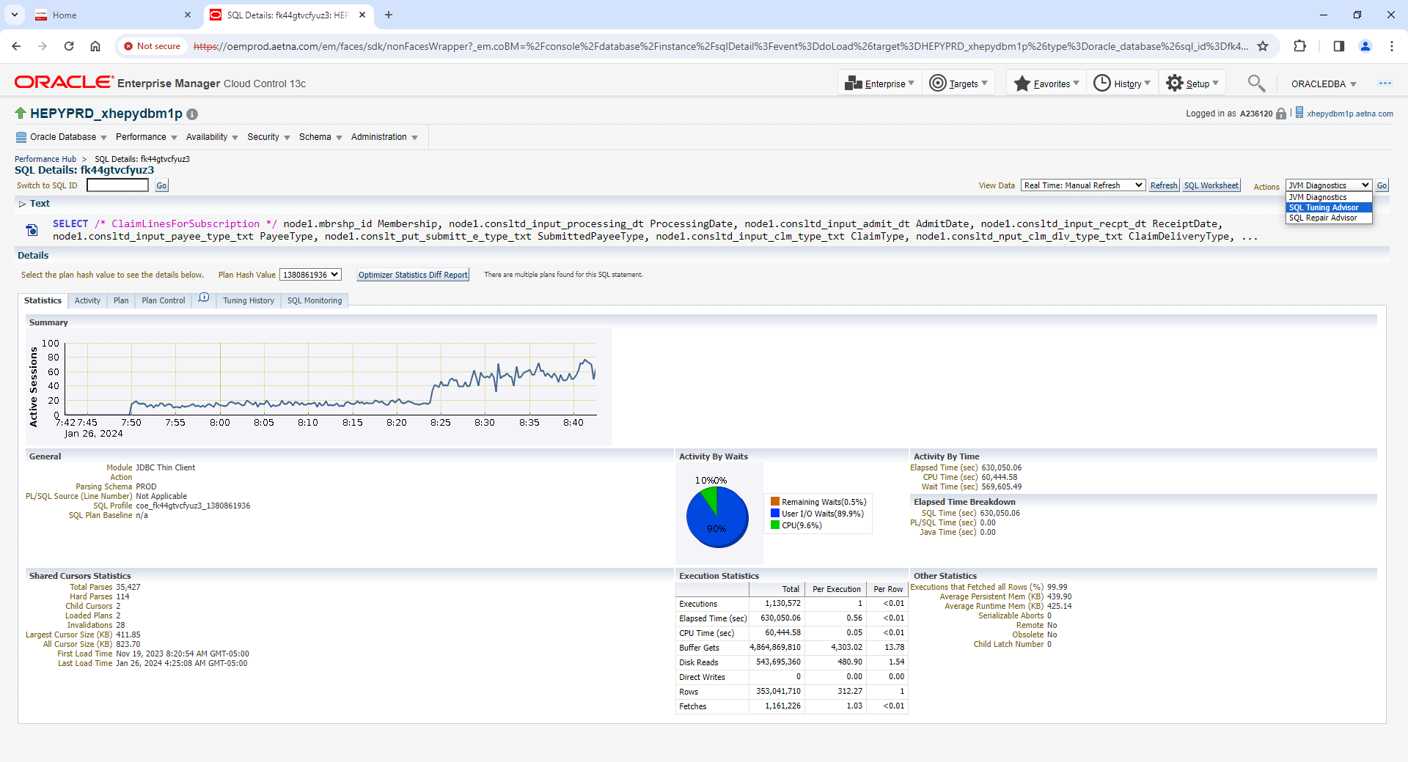

**Provide meaningful descriptions (I normally paste SQL ID and maybe add my AID or date to it). You can leave 5 min Time Limit if it came back with Time Out error, next time increase Time Limit. Click Submit**

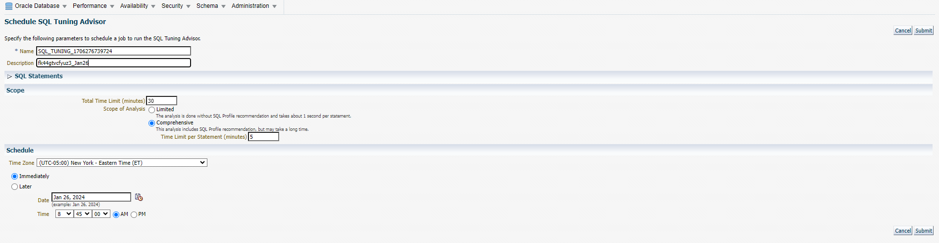

**Once you click Submit you will be presented with screen below. You can just stay on screen below or go to Advisors Home Screen to monitor Tuning Advisor Session Status. Wait till status turn to COMPLETED**

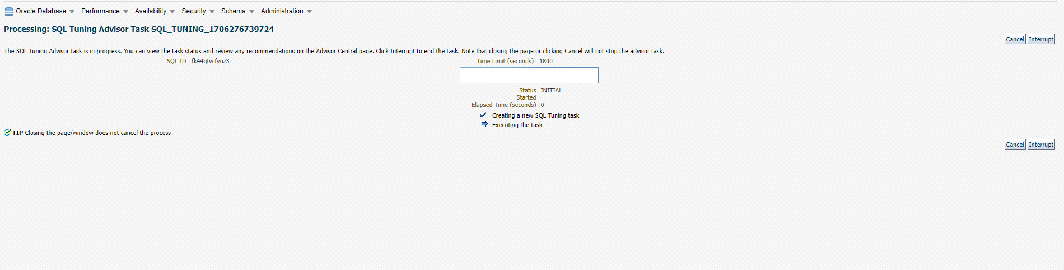

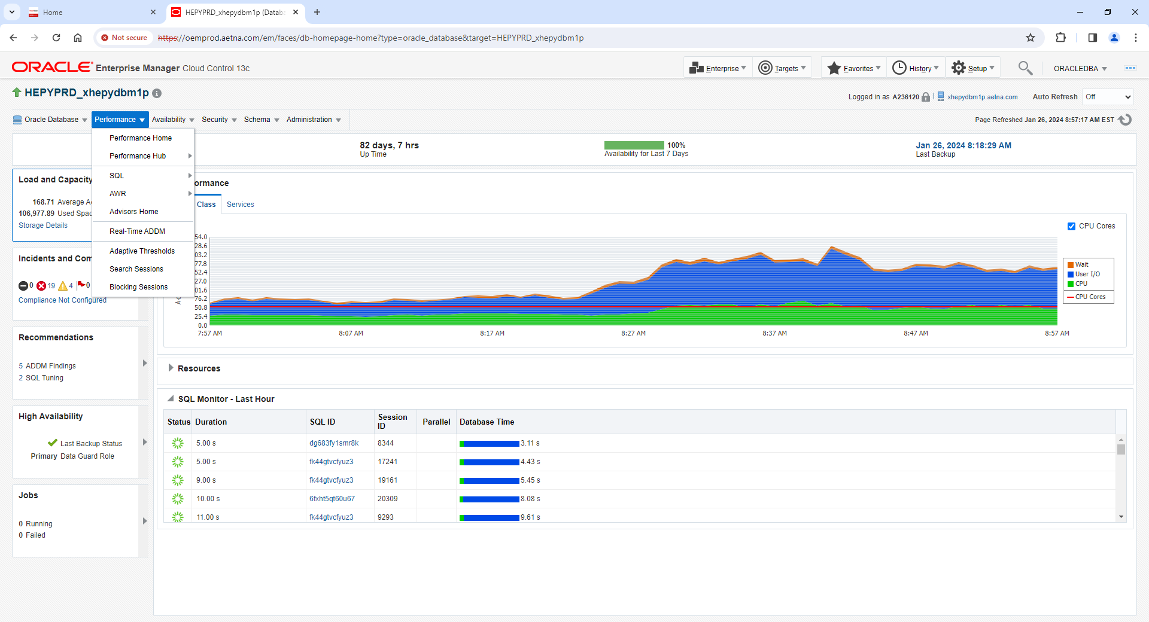

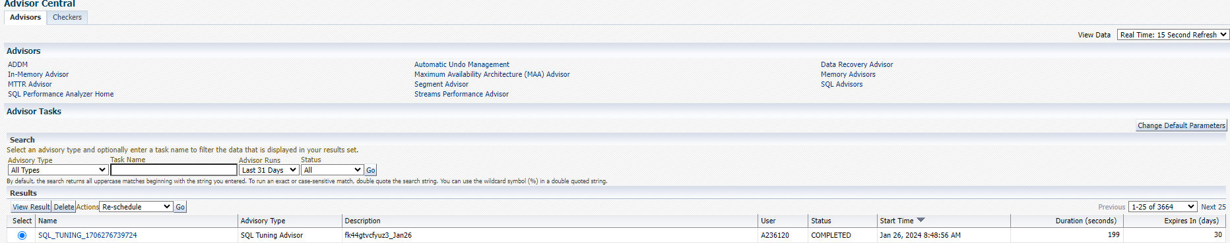

**Once status turns to COMPLETED you can select SQL Tunning Session and click on Name Link to see recommendations. As example below**

